DATASET IDENTIFICATION
Identify Dataset: The dataset is searched and identified from Kaggle.
This platforms offers a wide range of datasets in various domains.
Select Dataset: The dataset selected from Kaggle is the Stroke Prediction Dataset.
Download Dataset: The dataset is downloaded and its format is CSV
DATASET DESCRIPTION:
According to the World Health Organization (WHO) stroke is the 2nd leading cause of death globally, responsible for approximately 11% of total deaths.
This dataset is used to predict whether a patient is likely to get stroke based on the input parameters like gender, age, various diseases, and smoking status. Each row in the data provides relavant information about the patient.
ATTRIBUTE INFORMATION:
1) id: unique identifier
2) gender: "Male", "Female" or "Other"
3) age: age of the patient
4) hypertension: 0 if the patient doesn't have hypertension, 1 if the patient has hypertension
5) heart_disease: 0 if the patient doesn't have any heart diseases, 1 if the patient has a heart disease
6) ever_married: "No" or "Yes"
7) work_type: "children", "Govt_jov", "Never_worked", "Private" or "Self-employed"
8) Residence_type: "Rural" or "Urban"
9) avg_glucose_level: average glucose level in blood
10) bmi: body mass index
11) smoking_status: "formerly smoked", "never smoked", "smokes" or "Unknown"*
12) stroke: 1 if the patient had a stroke or 0 if not
STATISTICAL ANALYSIS
Performing a statistical analysis of raw data typically involves calculating various summary statistics, visualizing the data, and potentially running hypothesis tests or regression analyses.
STEP1:Import the necessary libraries and load your data into a pandas DataFrame:
import pandas as pd
import scipy
import numpy as np
from sklearn.preprocessing import MinMaxScaler
import seaborn as sns
import matplotlib.pyplot as plt
STEP2:Load the data into a DataFrame
df = pd.read_csv('analysisstroke.csv')
STEP3:Describing data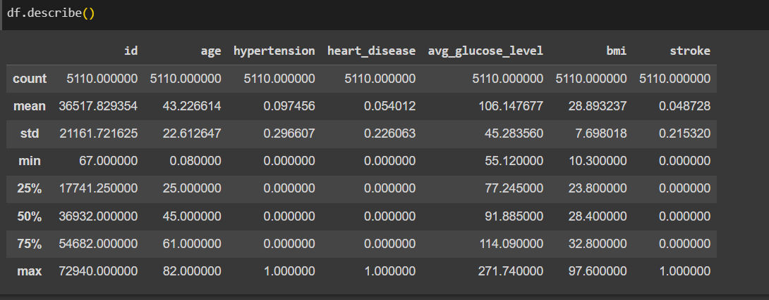
Summary Statistics:
Calculating basic summary statistics for numeric variables
Numeric variables:
numeric_summary = df[['age', 'avg_glucose_level', 'bmi']].describe()
print(numeric_summary)
Categorical Variables:
categorical_summary = data[['gender', 'ever_married', 'work_type', 'Residence_type', 'smoking_status']].value_counts()
print(categorical_summary)
Stroke and Other Binary Variables: Calculating the percentage of patients who had a stroke, hypertension, and heart disease
stroke_percentage = (df['stroke'].sum() / len(df)) * 100
hypertension_percentage = (df['hypertension'].sum() / len(df)) * 100
heart_disease_percentage = (df['heart_disease'].sum() / len(df)) * 100
print(f"Stroke Percentage: {stroke_percentage:.2f}%")
print(f"Hypertension Percentage: {hypertension_percentage:.2f}%")
print(f"Heart Disease Percentage: {heart_disease_percentage:.2f}%")
Correlation Matrix: Calculating the correlation matrix to understand the relationships between numeric variables
correlation_matrix = data[['age', 'avg_glucose_level', 'bmi']].corr()
sns.heatmap(correlation_matrix, annot=True, cmap='coolwarm', fmt=".2f")
plt.title('Correlation Matrix')
plt.show()
Data Analysis using Graphs:
Smoking status and Stroke occurrence with counts
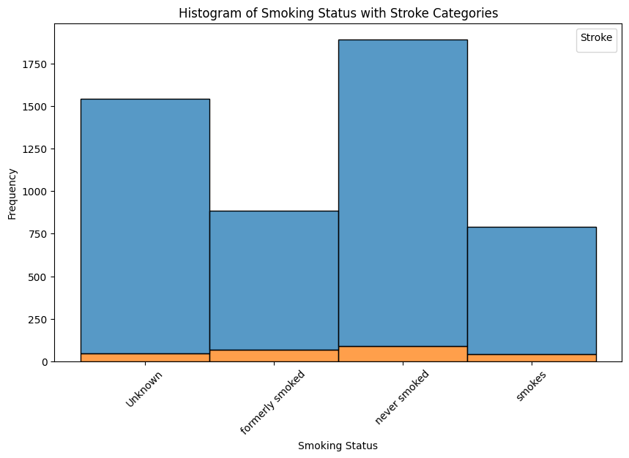
Hypertension and Stroke-Boxplot
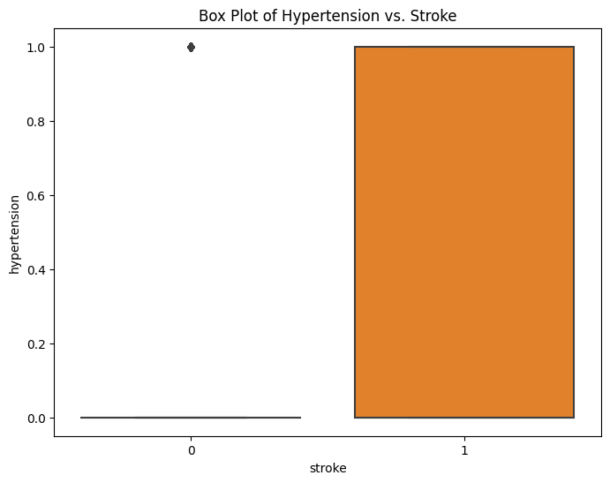
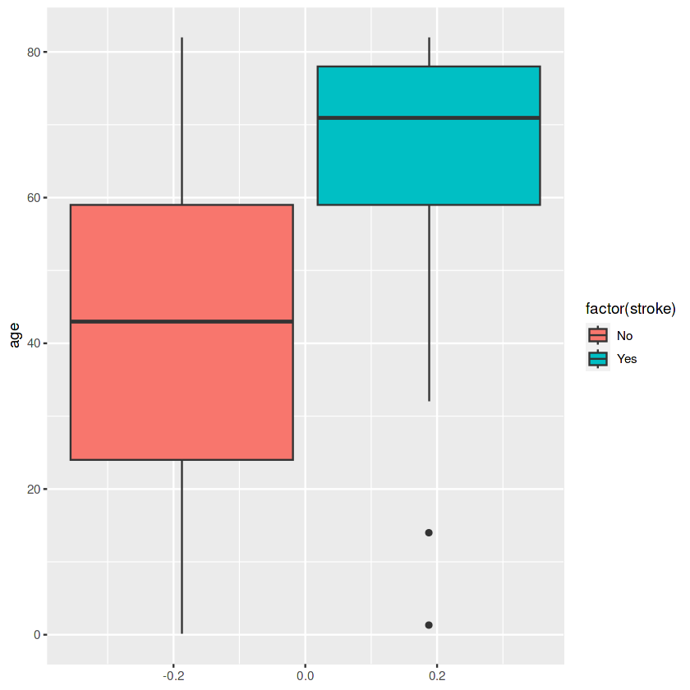

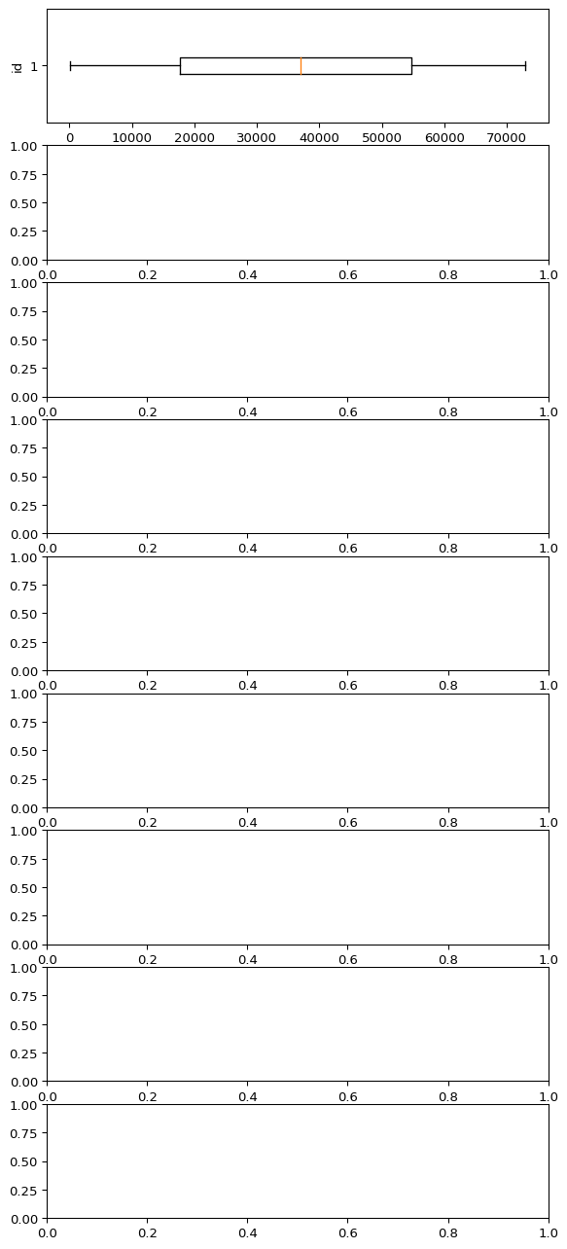
STROKE VS. ALL ATTRIBUTES -BOXPLOT
HANDLE THE MISSING VALUES.
Handling missing values is an important step in data preprocessing. In our dataset, "Unknown" in the smoking_status column represents missing values.
Step 1: Identify Missing Values This code will display the count of missing values in each column.
df.isnull().sum()
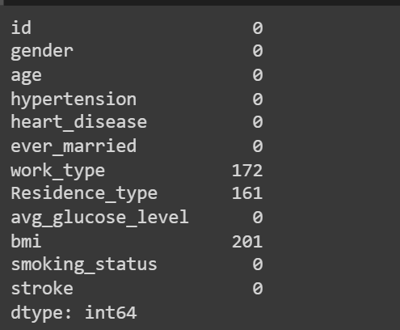
Step2:Decide How to Handle Missing Values There are several common strategies for handling missing values:
• Imputation: Fill in missing values with an appropriate value. For categorical variables like smoking_status, you can replace "Unknown" with the mode (most frequent category). You can use the mean, median, or a specific value that makes sense in your context for numeric variables.
• Dropping Rows or Columns: If missing values are limited, you can choose to drop rows or columns with missing values. However, this should be done with caution, as it may result in loss of valuable data.
Here for the bmi attribute we impude the value
mean_bmi = df['bmi'].mean()
df['bmi'].fillna(mean_bmi, inplace=True)

# Print the updated DataFrame
print(df)
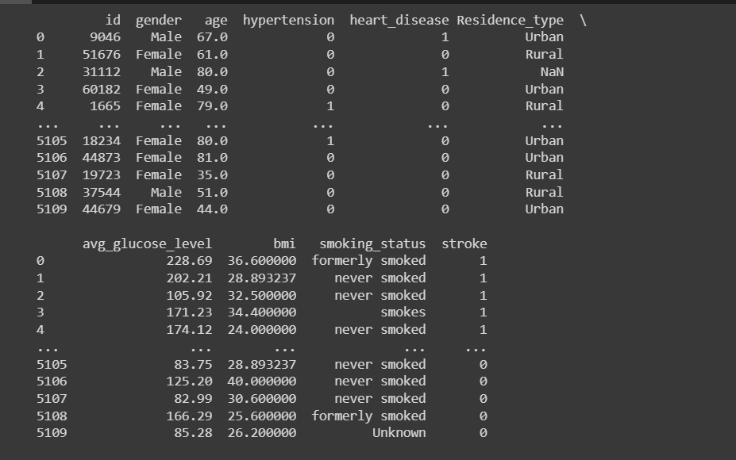
Here we drop off the columns that are not suitable for medical diagnosis
columns_to_drop = ['ever_married', 'work_type']
df.drop(columns=columns_to_drop, inplace=True)
print(df) # Print the updated DataFrame
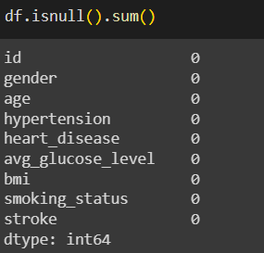
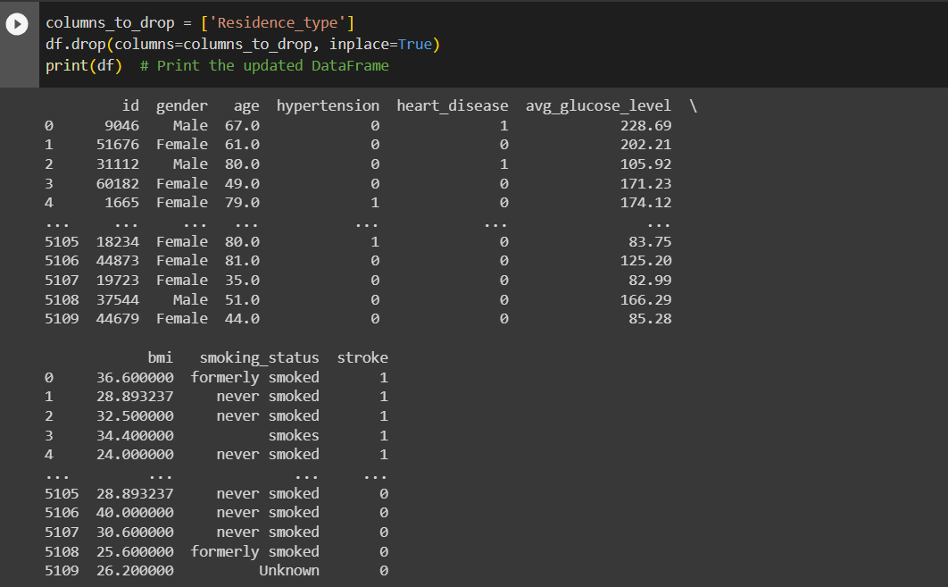
SELECT RELEVANT FEATURES BASED ON STATISTICAL (CORRELATION) ANALYSIS:
To select relevant features based on statistical analysis, we can calculate the correlation between each feature and the target variable (stroke) to identify which features have a strong relationship with the target.
corr = df.corr()
plt.figure(dpi=130)
sns.heatmap(df.corr(), annot=True, fmt= '.2f')
plt.show()
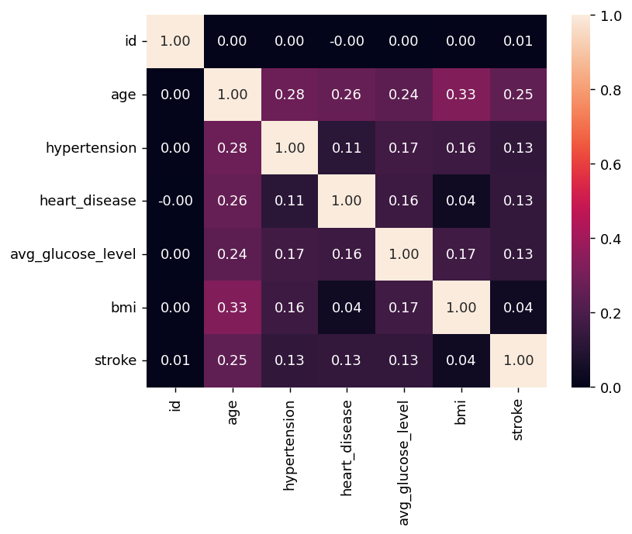

PERFORM CATEGORIZATION
Categorization of features involves converting categorical variables into a numerical format for use in machine learning models. We can achieve this through techniques like one-hot encoding or label encoding, depending on the nature of our categorical variables
import pandas as pd
from sklearn.preprocessing import Binarizer

# Create a dataframe
dT = pd.DataFrame({
'hypertension': [1, 0, 1, 0, 1]
})

# Create a binarizer object
binarizer = Binarizer(threshold=0.0)

# Fit the binarizer to the data
binarizer.fit(dT)

# Transform the data
binary_data = binarizer.transform(dT)

# Print the first 5 rows of the transformed data
print(binary_data[0:5,:])
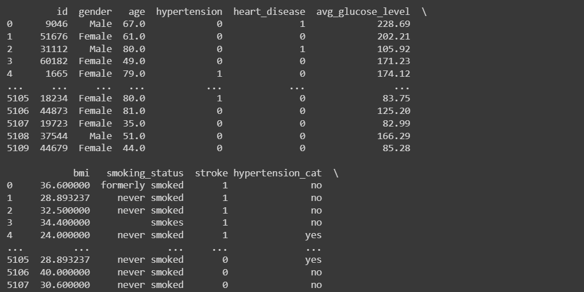
Normalization
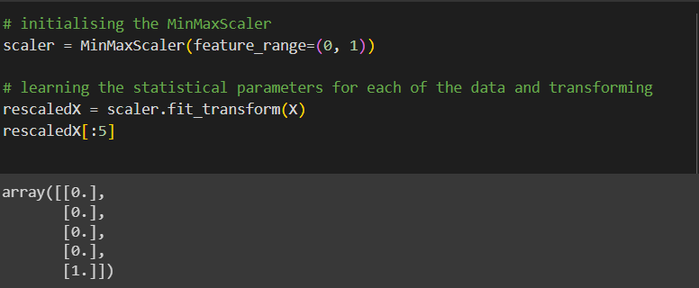
Standardization
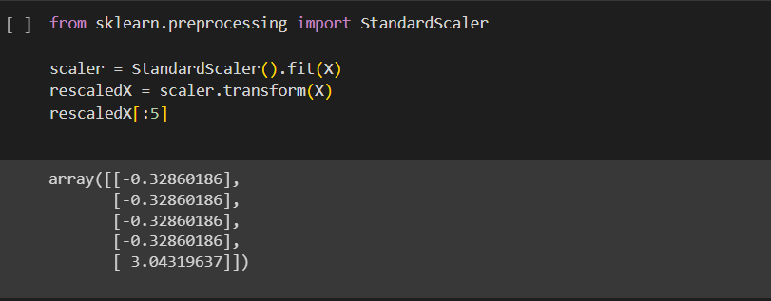
DATA ANALYSIS:
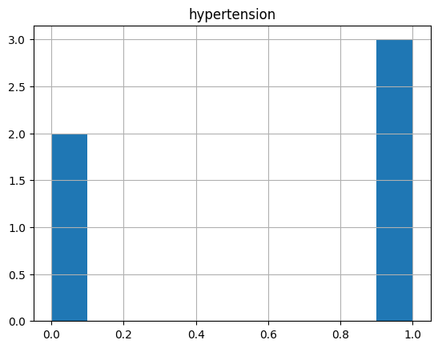
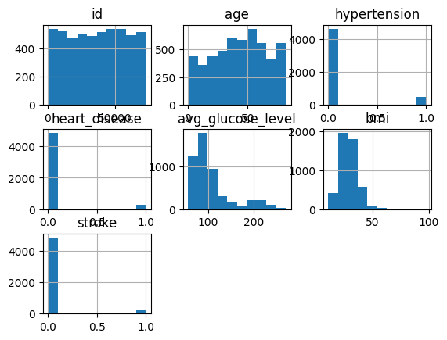
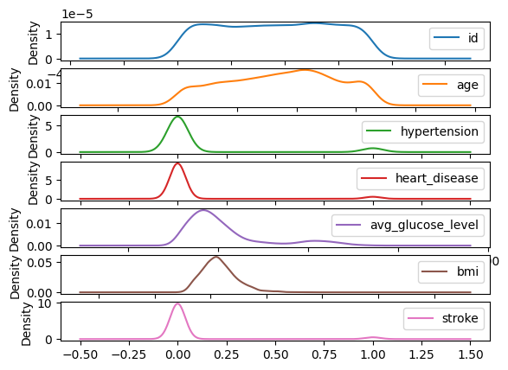

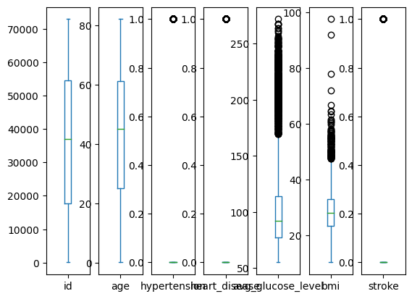
ANALYSIS BETWEEN CATEGORIZED VALUES:
import seaborn as sns
import matplotlib.pyplot as plt
# Assuming df is your DataFrame containing the data
# Make sure to have 'severity_cat,' 'bmi,' and 'smoking_status' columns
# Pivot the data to create a pivot table
pivot_table = df.pivot_table(index='severity_cat', columns='smoking_status', values='bmi', aggfunc='mean')
# Create the heatmap
plt.figure(figsize=(10, 6))
sns.heatmap(pivot_table, cmap='coolwarm', annot=True, fmt=".1f", linewidths=0.5)
plt.title('Heatmap of Severity, BMI, and Smoking Status')
plt.show()
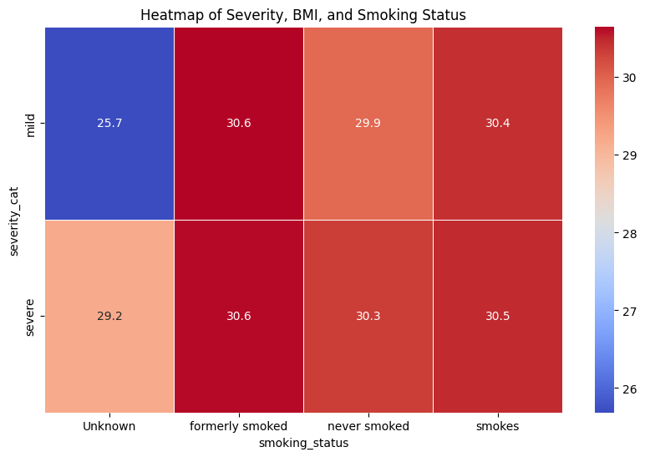
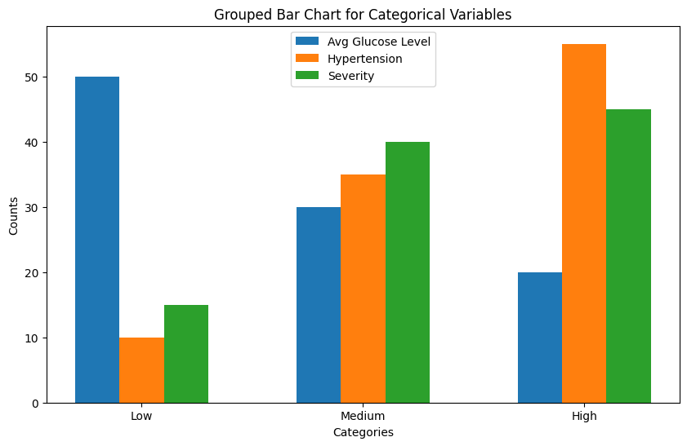
import matplotlib.pyplot as plt
import numpy as np
# Example data (replace with your data)
categories = ['Low', 'Medium', 'High']
avg_glucose_counts = [50, 30, 20] # Replace with your counts for each category
hypertension_counts = [10, 35, 55] # Replace with your counts for each category
severity_counts = [15, 40, 45] # Replace with your counts for each category

# Create an index for the x-axis (the number of categories)
x = np.arange(len(categories))

# Define the width of the bars
bar_width = 0.2

# Create the grouped bar chart
plt.figure(figsize=(10, 6))
plt.bar(x - bar_width, avg_glucose_counts, bar_width, label='Avg Glucose Level')
plt.bar(x, hypertension_counts, bar_width, label='Hypertension')
plt.bar(x + bar_width, severity_counts, bar_width, label='Severity')
# Add labels, title, and legend
plt.xlabel('Categories')
plt.ylabel('Counts')
plt.title('Grouped Bar Chart for Categorical Variables')
plt.xticks(x, categories)
plt.legend()
plt.show()
To save modified dataset
data.to_csv("encoded_data.csv", index=False) By performing this categorization, we have prepared our data for machine learning algorithms that require numerical input.
REFERENCES:
https://www.kdnuggets.com/2020/07/easy-guide-data-preprocessing-python.html
https://www.geeksforgeeks.org/data-preprocessing-in-python/
https://www.analyticsvidhya.com/blog/2021/08/data-preprocessing-in-data-mining-a-hands-on-guide/

